HOW TO INSTALL PRINTER RICOH SP2501

Open www.google.com and search ricoh sp 2501 and Click the first link

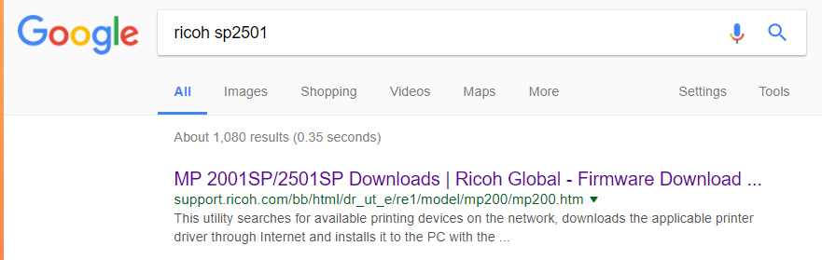
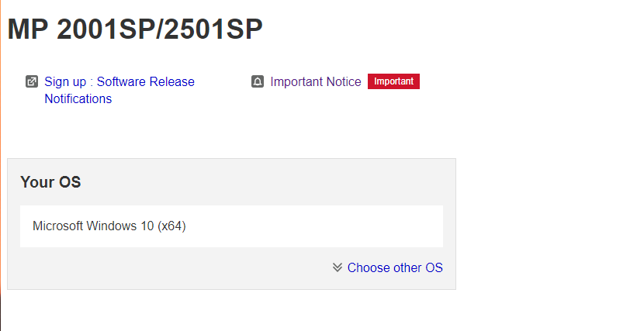

Your os will be recognized and scroll down to to find
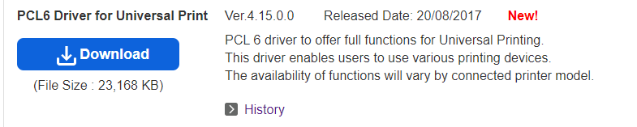
And click download

Run the donwloaded file i.e. z80738L17.exe
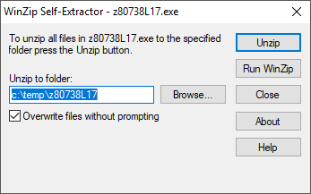 click unzip

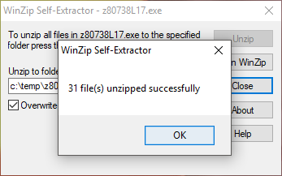 and Click ok.

Open control panel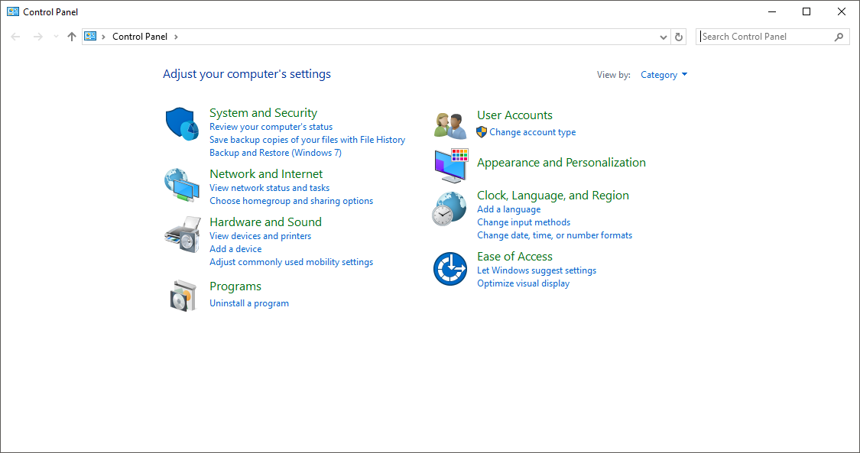

Open hardware and sound
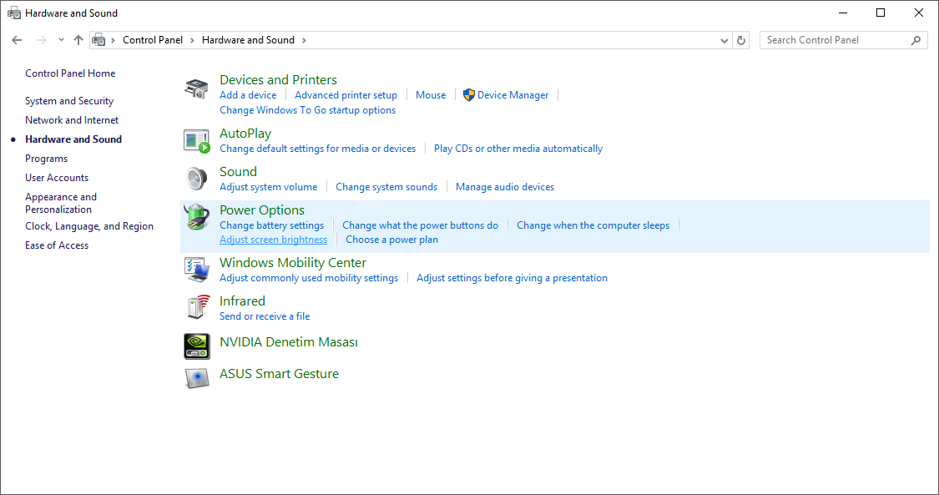

Open devices and printers
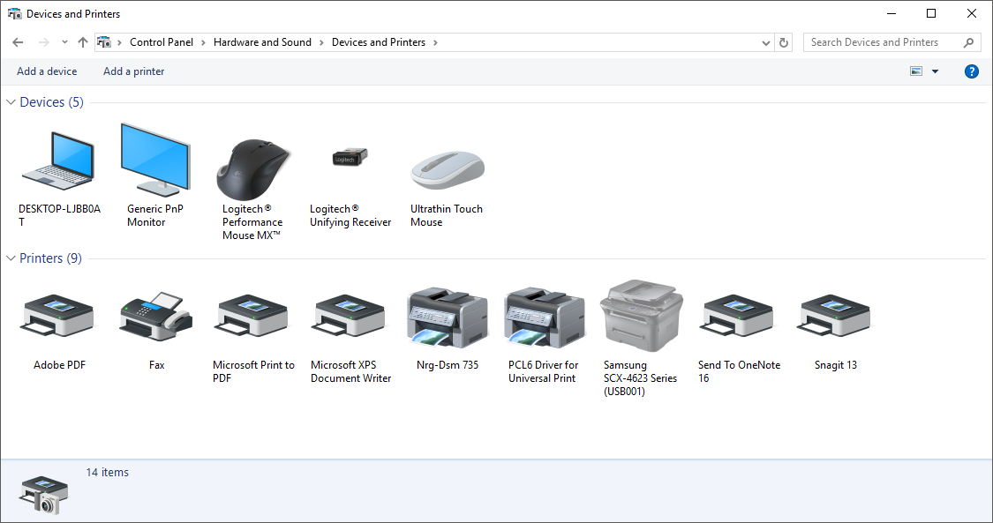

Click “add a printer” and then click “The printer that I want isn’t listed”
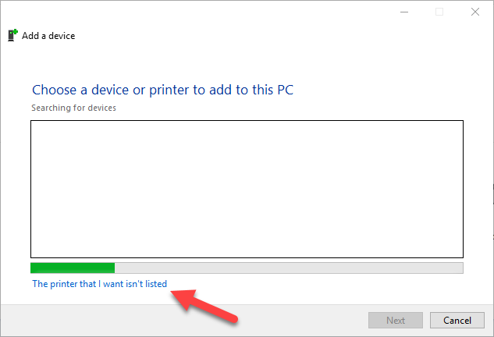

Choose “Add a printer using a TCP/IP ....”
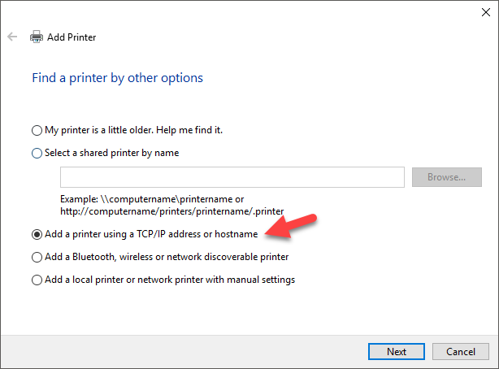
And next

Choose and fill Hostname or IP adress as 10.2.19.192
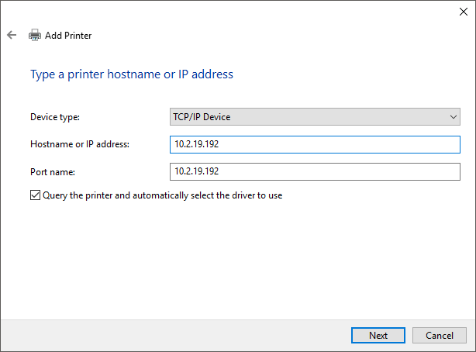
And next

Click have disk
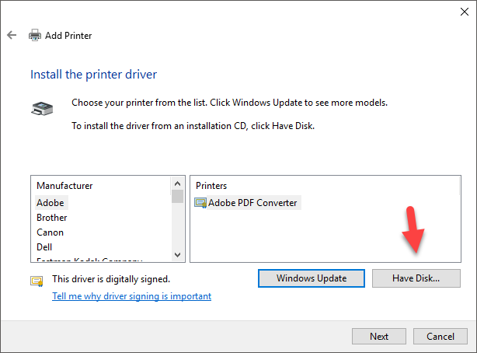

Click browse
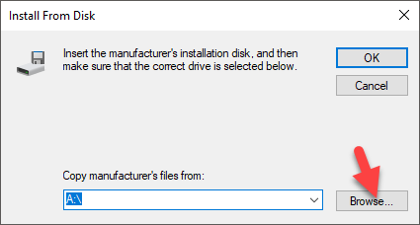
Choose local disk c
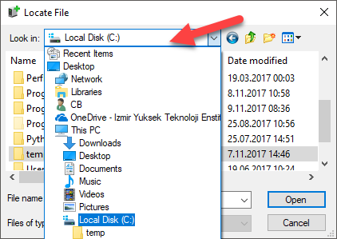

Click temp
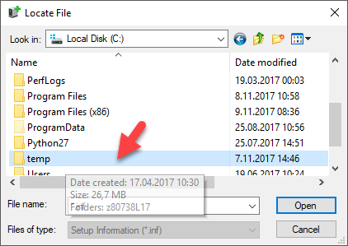

Click the folder which has the same name with your extracted driver file
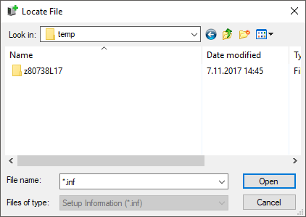

Click disk1
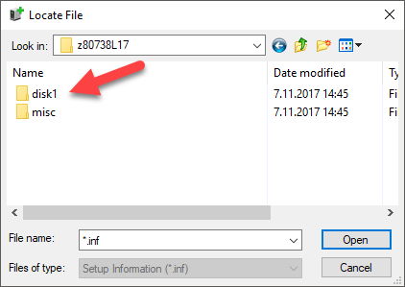

Select oemsetup
The open and ok

Choose first one and click next
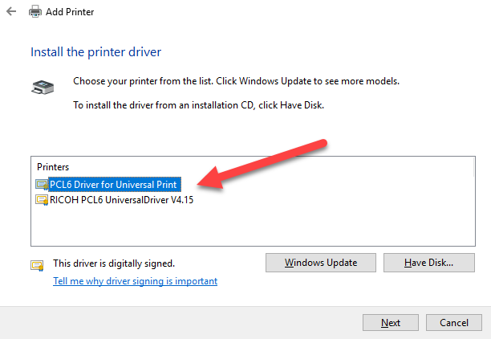
and print test page to complete the installation

