HOW TO INSTALL PRINTER RICOH SP2501
Open control panel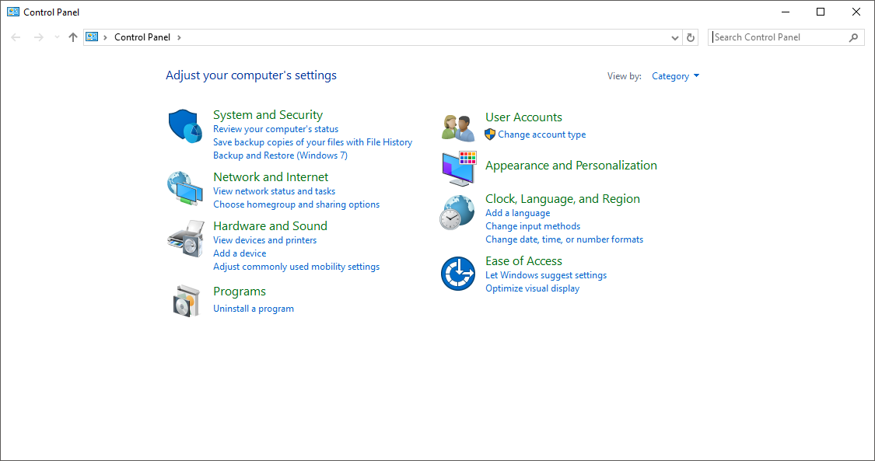

Open hardware and sound
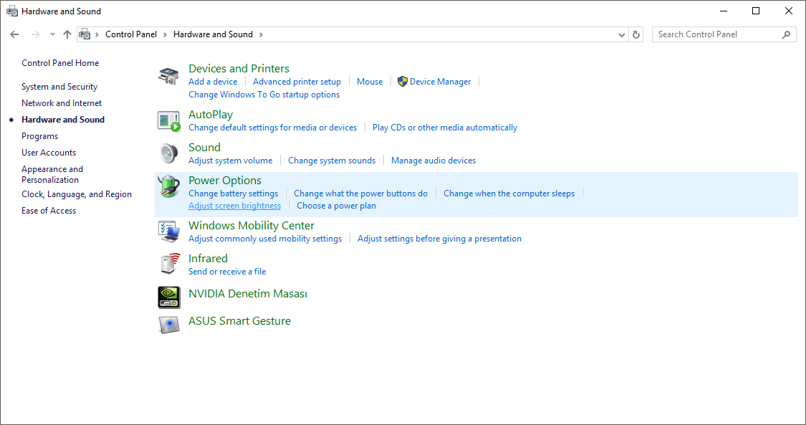

Open devices and printers
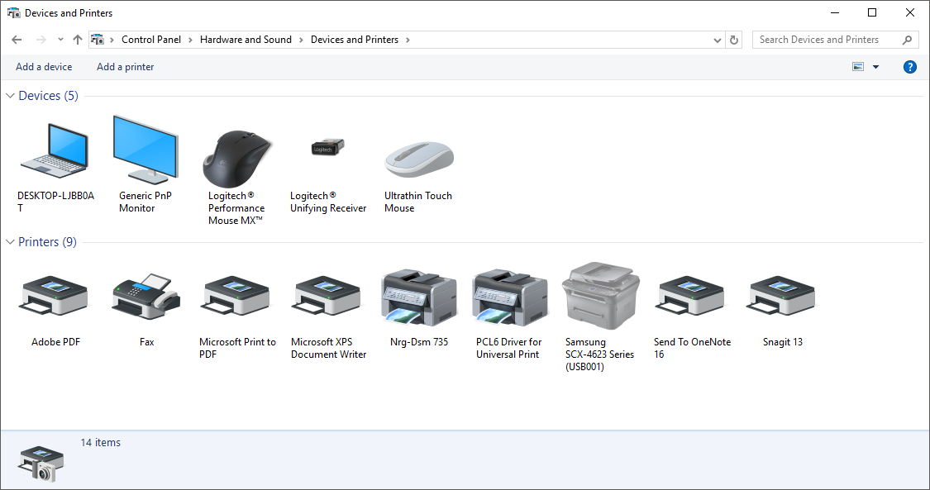

Click add a printer
If listed select RICOH MP 2501 and click next (If not open other word document to install manually)
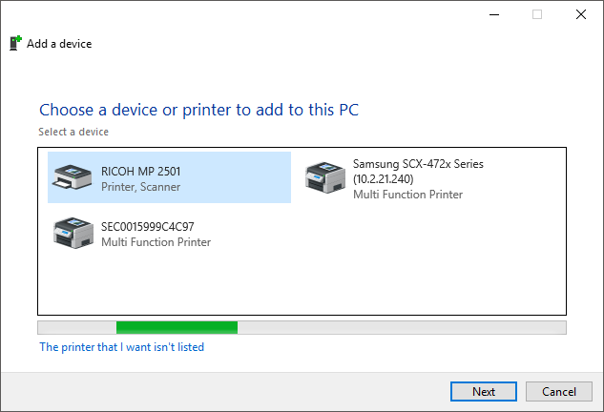

To check, print a test page
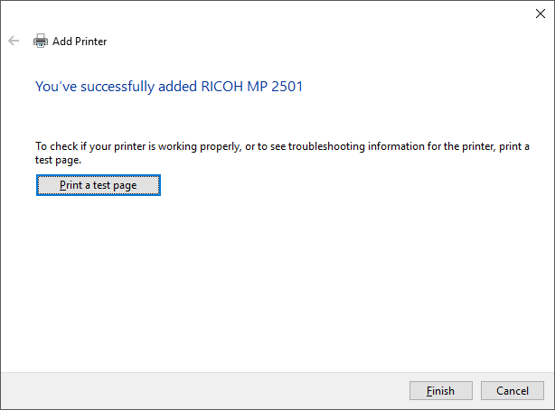
And click finish

